Implementation: Simple Arithmetic Calculator using Lex & YACC
This calculator is built using Lex and YACC, two tools commonly used in compiler design. It evaluates basic arithmetic expressions such as addition and subtraction and demonstrates operator precedence.

Supported Operations
- Addition (+)
- Subtraction (-)
Multiplication (*) and division (/) can be added similarly by extending grammar rules, but this current version focuses on addition and subtraction for simplicity.

Lex File (calc.l)
The Lex file acts as the lexical analyzer. Its job is to read the input character by character, identify numbers and operators, and pass them to the parser.

Token Examples
Pattern | Meaning
[0-9]+ | Matches integer numbers
[+] | Matches addition operator
[-] | Matches subtraction operator
[ \t] | Ignores whitespace
[\n] | Signals end of input

Lex Code Snippet
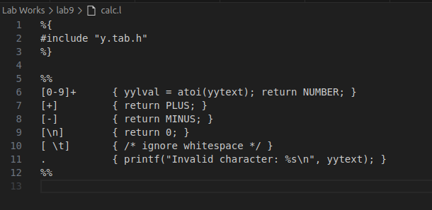

YACC File (calc.y)
The YACC file acts as the parser. It defines grammar rules and evaluates expressions according to operator precedence.

Grammar Rule Example
expression:
expression PLUS expression { $$ = $1 + $3; printf("Result = %d\n", $$); }
| expression MINUS expression { $$ = $1 - $3; printf("Result = %d\n", $$); }
| NUMBER { $$ = $1; }
;
- This rule allows adding or subtracting two expressions.
- When the parser matches a pattern, it computes the result and prints it immediately.

Error Handling
void yyerror(char *s) {
printf("Error: %s\n", s);
}
- Any invalid input is handled gracefully with an error message.

Code Snippet
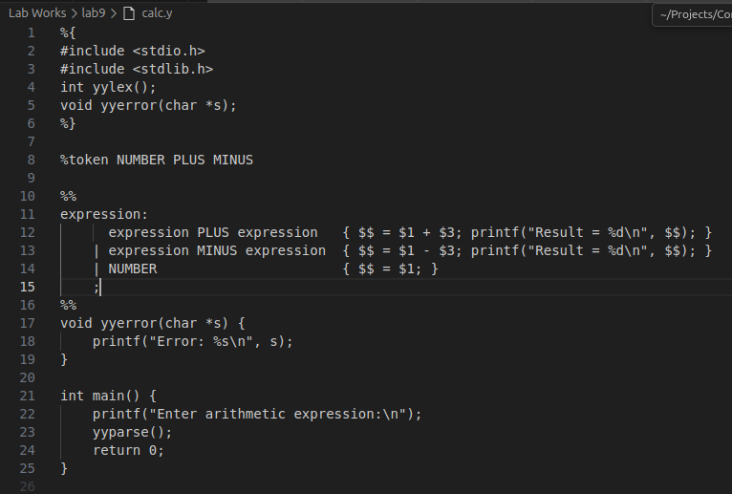

Sample Input / Output
Input:
5 + 10 - 3
Output:
Result = 15
Result = 12
The parser evaluates left to right according to the grammar rules.

Conclusion
- This project demonstrates how Lex identifies tokens and YACC parses and evaluates expressions.
- It shows the core concepts of lexical analysis and syntax analysis in a compiler.
- Students learn how a simple calculator can be implemented by breaking down expressions into tokens and applying grammar rules.

